Ch. 6.1-3 Graph

1. Share to the class an application using the graph data structure.

(a) Before you find out any reference implementations, propose your own solution.

(b) After you find the reference implementation, share it to the class.

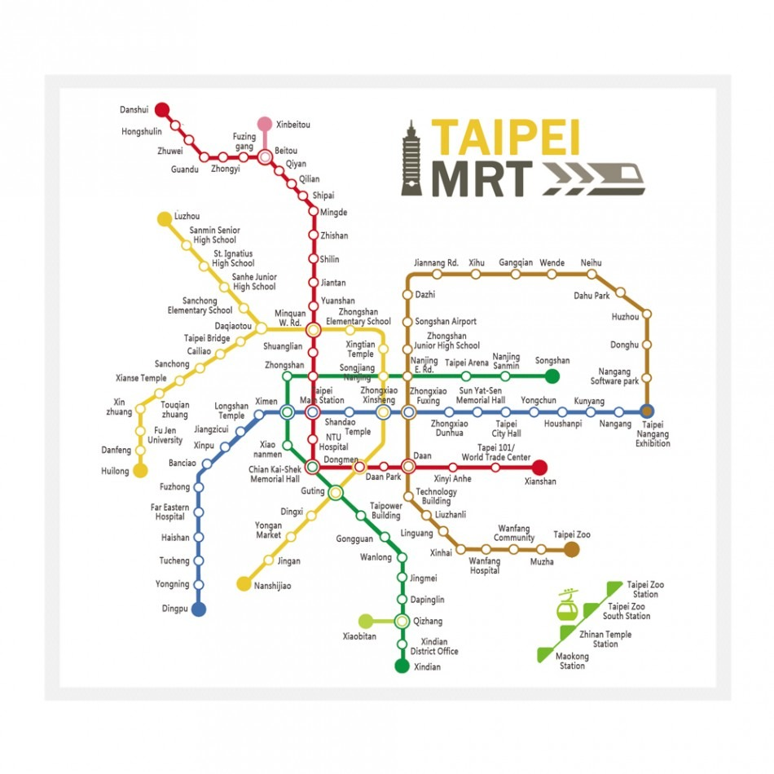

* For example, one Taipei MRT **(You should propose a new application by yourself)** APP can plan your trip from one starting point to an end point with the lowest cost. You may guess that the developer used a database to store the information of all MRT stations, and wrote an APP to analyze the Shortest Path of the weighted graph. This is just the initial idea that you have, you should search for how the developers actually implemented the solution and share your finding to the class.

1. Can you use an adjacency matrix to represent the following graph? If yes, show your adjacency matrix; otherwise, show how you can represent the graph.

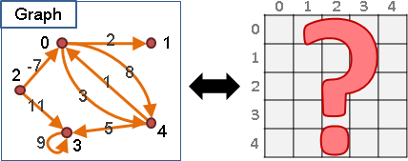

1. (a) Explain the concept of BFS and DFS, and show the BFS and DFS search sequence of the following graph.

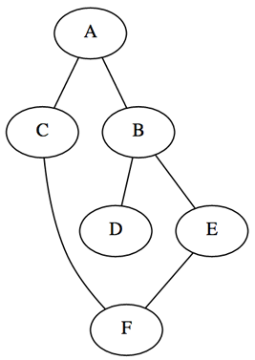

(b) Can you use the BFS to search a Tree data structure? If so, what is the equivalent tree traversal algorithm.

1. Please propose a method to determine whether a graph is cyclic, i.e. there exist cycles in the graph. You may try to adapt the DFS algorithm to solve this problem.

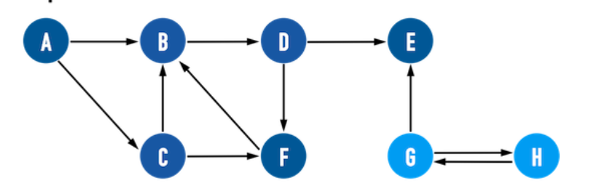

1. Please represent the following graph using an incidence matrix

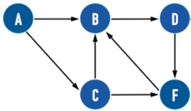

1. Prove that the minimum weight edge of a graph must be included in the MST if every edge of the graph is of different weight .
2. Design a method of the Prim’s algorithm such that the time complexity is

$O(V\log{V} + E\log{V}) or O(E\log{V})$.

1. Truth or False: any two Spanning Trees of a connected undirected graph must have at least one common edge.
2. The graph edges can be divided into four categories after DFS. Please write down their definitions respectively.
   1. **Tree edge**
   2. **Back edge**
   3. **Forward edge**
   4. **Cross edge**
3. An **articulation vertex** of a connected graph is a **vertex** whose removal will disconnect the graph.

(a) Please describe how to use the DFS to find all the articulation vertices in a graph and (b) estimate its time complexity.

1. (a) Please describe the definition of **strongly connected components (SCC)**,

(b) and use the DFS twice to find out the SCC belonging to the following undirected graph.

Optional: Prove why this approach can indeed find the SCC ?

